**Review – Chemistry Fall Exam Key**

1. A-heating water with an open flame because acetone is volatile and flammable
2. 56.0 ml
3. Group 2
4. 1000 mm =1 m
5. 4.100009x103
6. 6 sig figs in 505,000
7. Largest unit = KL
8. 5km 1000m 1000mm = **5,000,000 mm**

**1 1km 1m**

K h d unit d c m -move decimal 6 places to right

1. **10 000mL 1L = 10L**

**1 1000mL**

1. Density= mass/volume (55.08)/(2.5 x 1.8 x 5.0) = (55.08)/(22.5) = 2.448 = **2.4 g/cm3**
   1. *volume can be measured in cm3

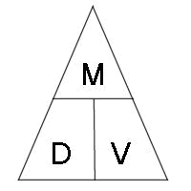

1. (7.14)(250) = 1785 g = **1800g *final answer can only have 2 sig figs**
2. For an object to sink the object must have a greater density than the liquid it was placed in.

For example: The bowling ball floats if density was less than 1 g/mL (density of water) and sank if greater

1. Dilute with water! Add baking soda powder
2. M=A+N 20+23= 53 mass number
3. Isotope = same number of p+ and e- ; different number of n0
4. Proton
5. A=P=E M-A=N Atomic # = 94 210

P+ = 94 - 94_

e- = 94 **116 neutrons**

1. The periodic table elements are arranged from increasing atomic number (contribution by Henry Mosely)
2. Metalloids are found along the Zig Zag Line between the metals and nonmetals; hence they have metal and nonmetal properties
3. Group Or Family
4. Rusting is a chemical change
5. SO2 because 2 nonmetals
6. Cl2 and I2 REMEMBER Br2 I2 N2 Cl2 H2 O2 F2 , Magic 7,7,7 ; there are 7 diatomic elements, the first one starts at the atomic number 7, and it looks like a 7 on the periodic table.
7. K2S *ionic🡪 remember to balance the charges
8. PbF2 Ionic🡪 balance charges (roman numeral = charge)
9. CaSO4 = calcium Sulfate
10. N2O4 = Dinitrogen Tetraoxide
11. Ba = 2+ Br = -1 *need to criss cross so = BaBr2
12. Group 15 Row 3 is phosphorus nonmetal
13. S = 6 Valence e- in group 6A

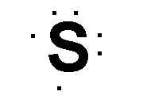

2. N and P have most similar properties because they are in the same family; hence, they have the same number of valance electrons
3. Beta beta%20particle zero mass
4. Fusion because the separate particles become 1 on the product side



1. **4**

**2**

1. Neon; F-1 1s22s22p6 isoelectronic with Neon because they have the same electron configuration but they are not the same element.
2. Noble gases are inert. The noble gases do not react with other elements due to having full octets- having 8 valance electrons.
3. Chemical change- we know this because the wick turns black after being burned. *it was burned and there was a color change
4. Alka seltzer released more gas
5. Leave the room!! Make sure gas is off! Call the fire department
6. X is a noble gas; required the most energy to remove an electron from outer level
7. 3 physical properties of metals: (there are more than 3)

|  |  |
| --- | --- |
| High melting point | High boiling point |
| Good conductor of heat and electricity | Ductile |
| Malleable | Lustrous |

1. BaO = ionic because compound begins with a metal
2. N2O5 dinitrogen pentox**ide**
3. Na🡪 sodium
4. H2O polar covalent

Helpful things to notice from the choices given in #46:

H2 is completely non polar because equal amount of electro negativity between the elements means no unequal sharing of valance electrons.

NaCl is ionic due to sodium being a metal. Therefore, when compounds begin with metals they are considered ionic and transfer electrons; Huge difference between the electro negativities.

1. Decrease ionization energy going down a family/group

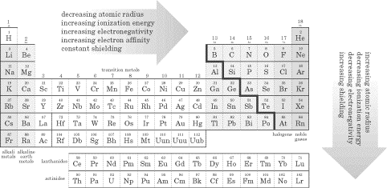

1. Increase atomic radius

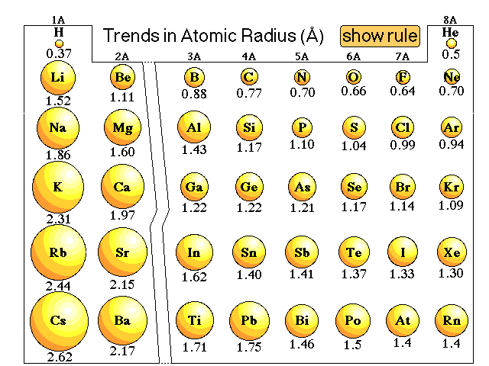

* 1. sodium = 1 valance e- 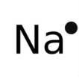
  2. Calcium = 2 valance e-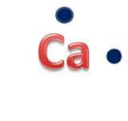
  3. Nitrogen = 5 valance e- 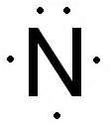
  4. Sulfur = 6 valance e- 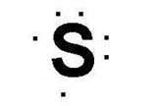

1. CCl4

N 8+8(4) = 40

A 4+7(4) = 32

S 40-36= 8

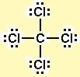 tetrahedral/ non polar

1. Electromagnetic spectrum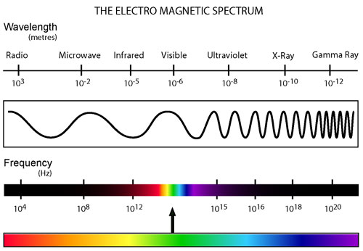

Long wavelength ----------------------------------------------------------------------short wavelength

Low energy ------------------------------------------------------------------------------high energy

Low frequency------------------------------------------------------------------------------high frequency

1. NO
2. A. sugar= pure substance
3. CO2 covalent KF ionic Zn metallic bonding
4. K potassium *metals become cations because they lose e-
5. %error = I actual – experimental I *100 =

Actual

11.35-10.42 x 100 = 8.2%

11.35